QUESTION 1

#Write a R program to create a sequence of numbers from 20 to 50 and

#find the mean of numbers from 20 to 60 and sum of numbers from 51 to 91.

print(seq(20,50))

print(paste("the mean of numbers from 20 to 60 is ",mean(20:60)))

print(paste("sum of no. from 51 to 91 is ",sum(51:91)))

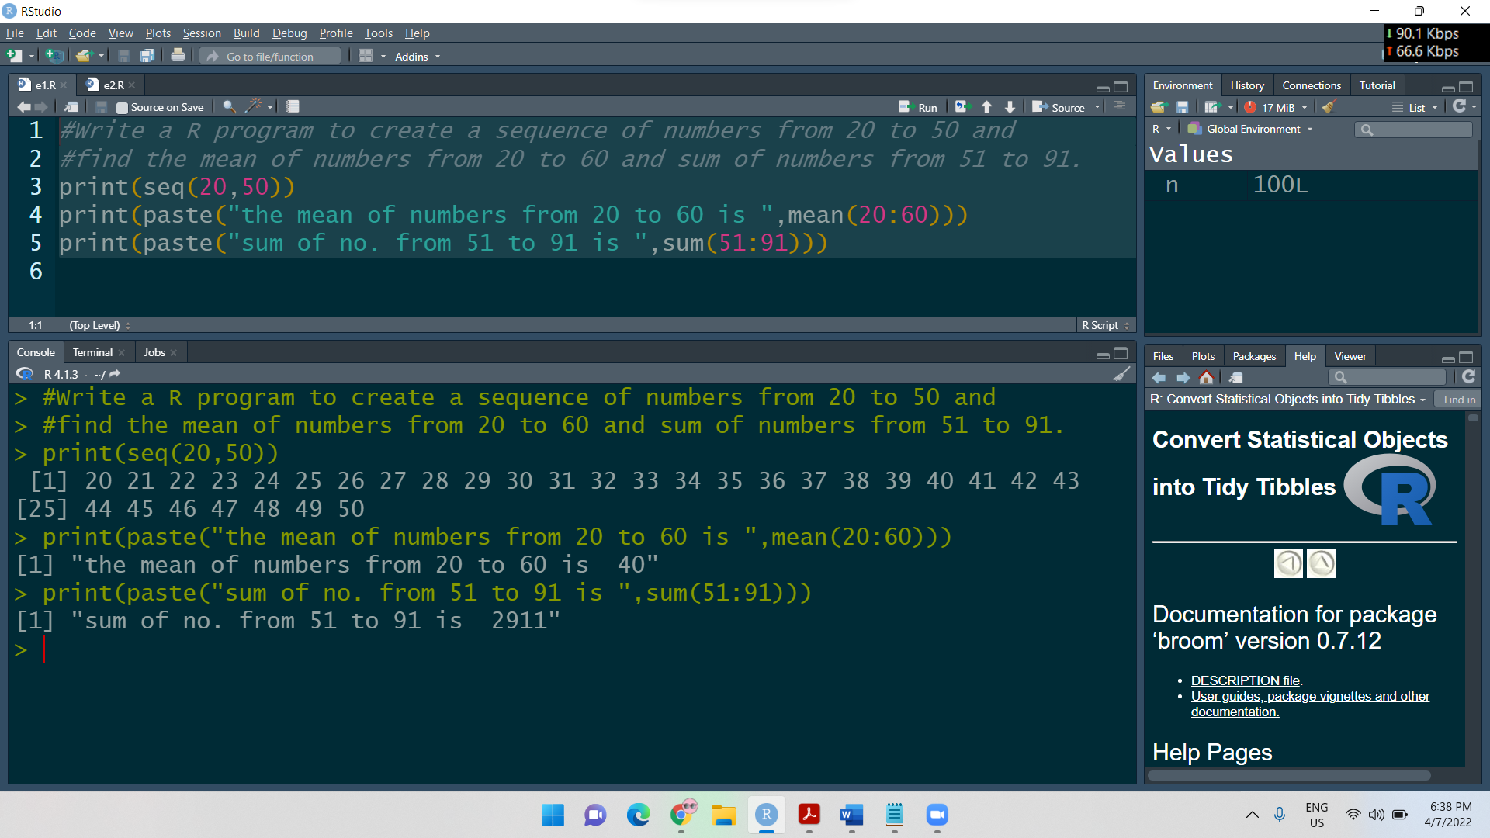

QUESTION 2: #Write a R program to print the numbers from 1 to 100 and print "Fizz"

#for multiples of 3, print "Buzz" for multiples of 5, and

#print "FizzBuzz" for multiples of both.

for (n in 1:100){

if (n %% 3 ==0 & n %%5 == 0) {print("FizzBuzz")}

else if (n %%3 == 0) {print("Fizz")}

else if (n %% 5 == 0) {print("Buzz")}

else print(n)

}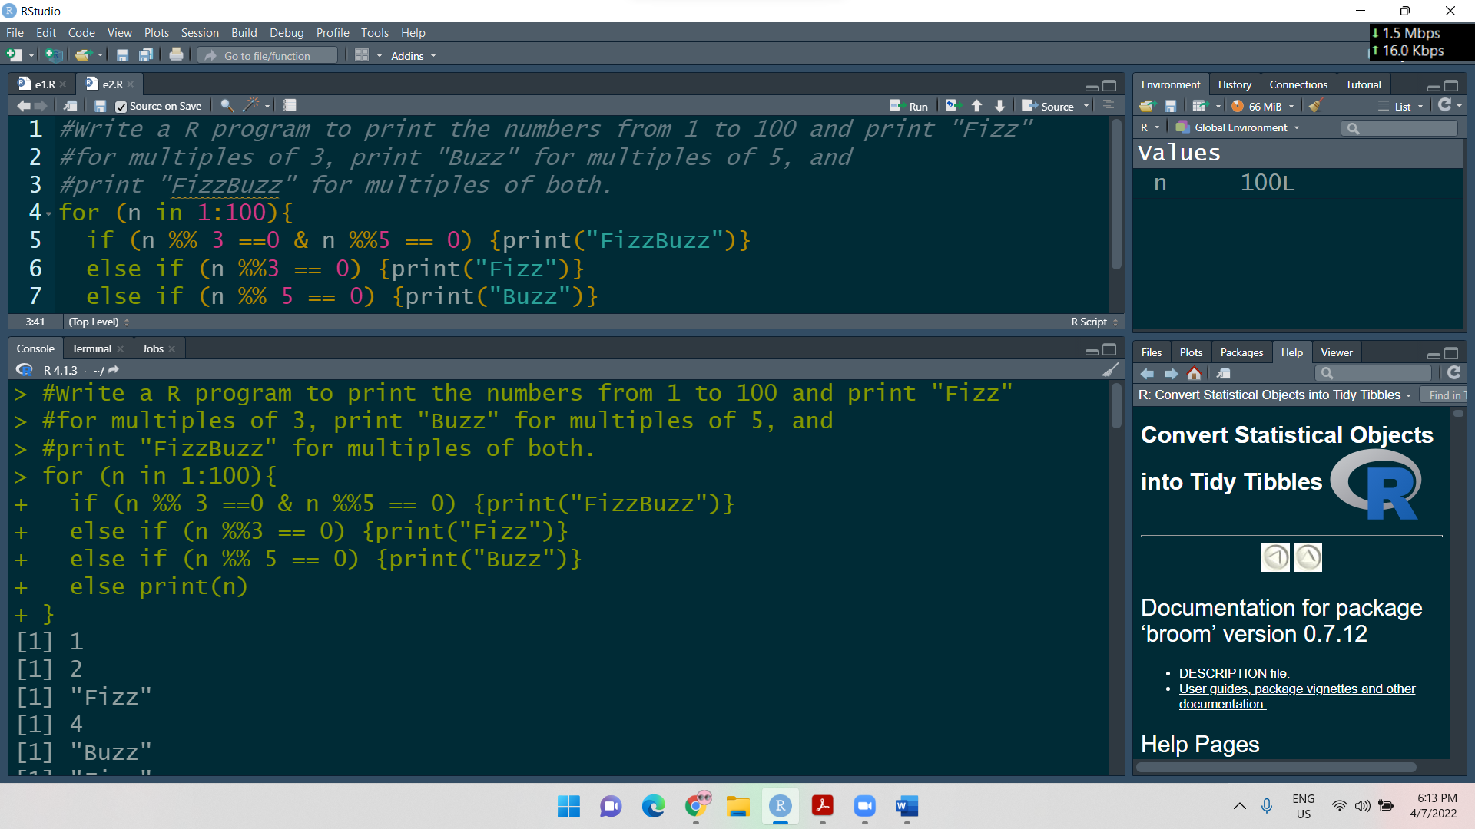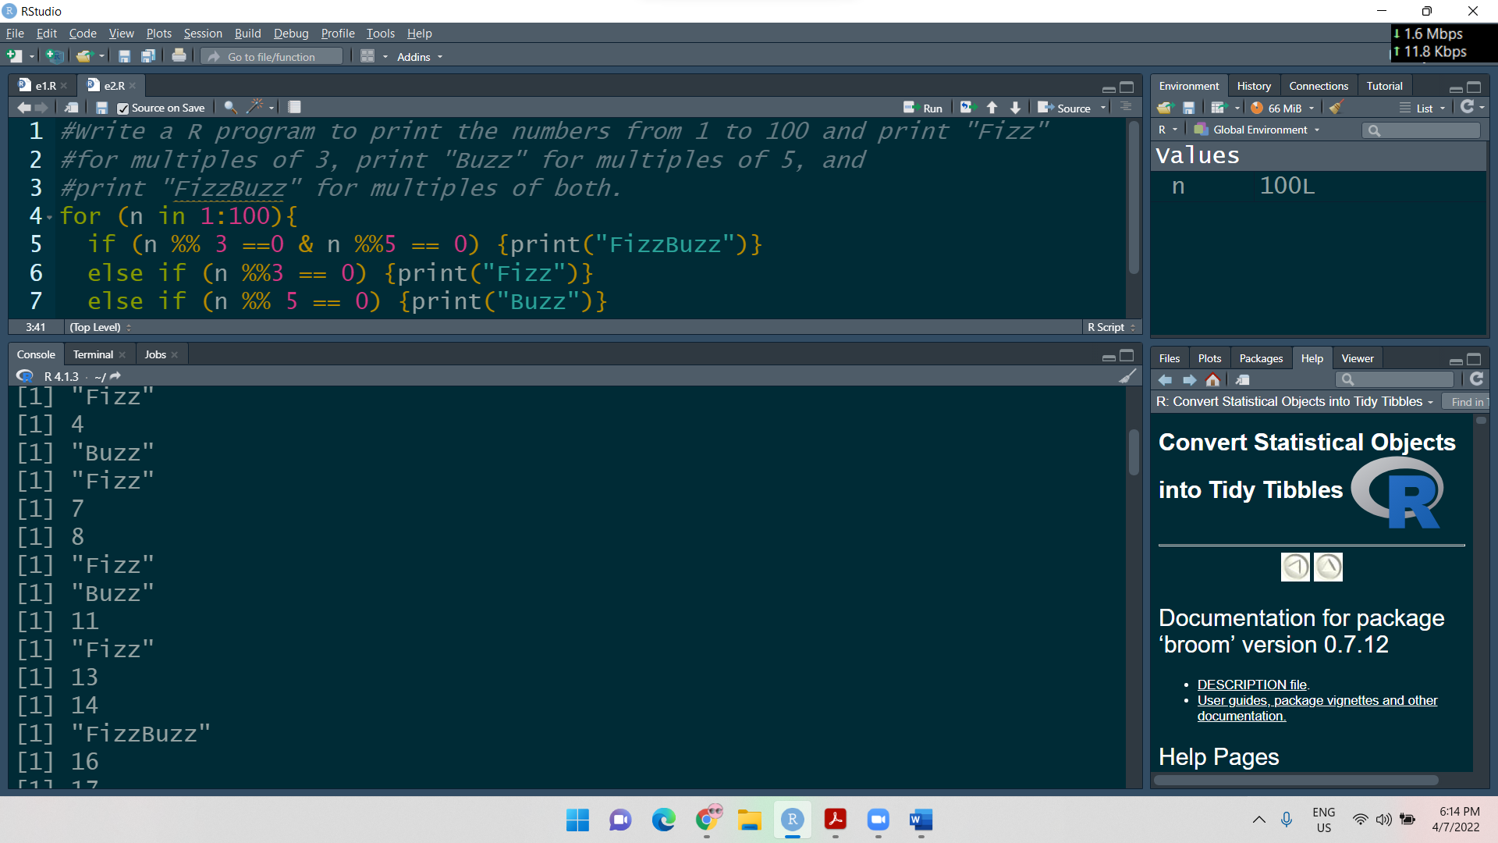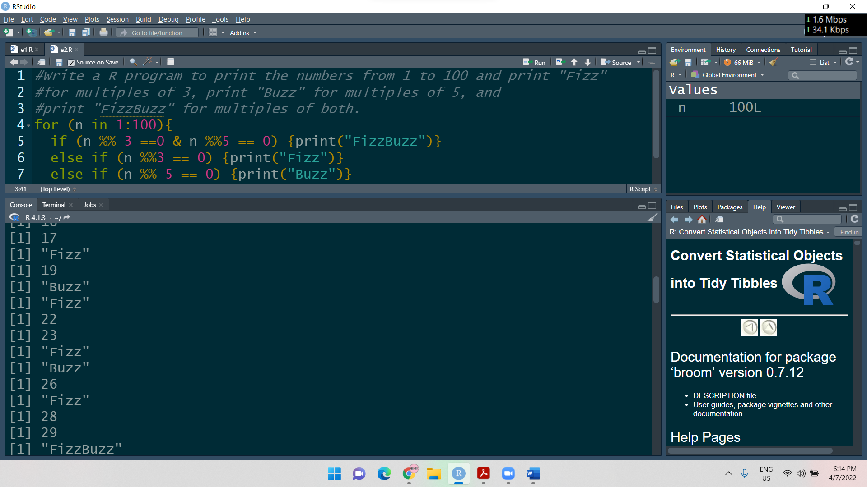….

.

.

.

.

Last screenshot:

